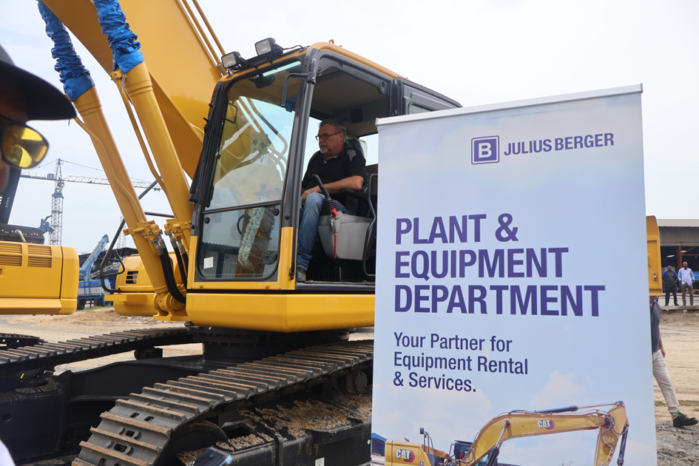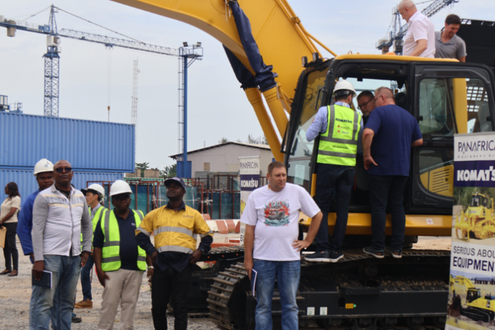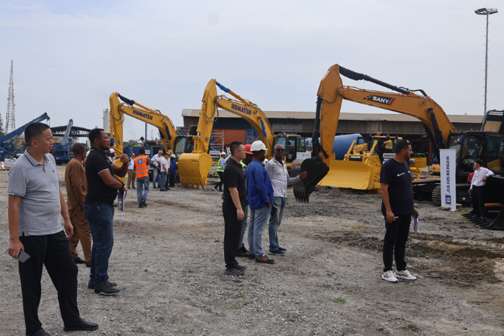Cross section of exhibitors and equipment on display at the one-day global specialist equipment fair hosted by the Plant and Equipment Department, PED of Julius Berger Nigeria PLC in Lagos, recently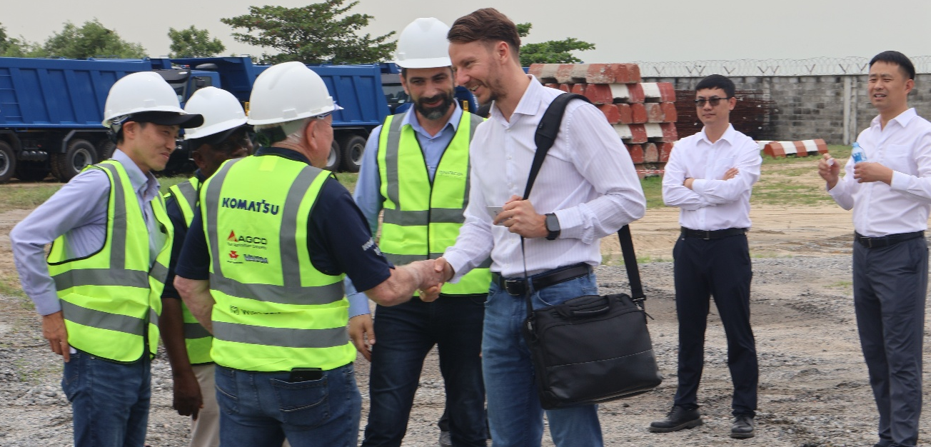
L-R: Head, Plant and Equipment, Julius Berger Nigeria PLC, Nico Trostawicki exchanging pleasantries with representatives of Komatsu Equipment manufacturers, while officials of truck crane specialists, XCMG, standing behind, look on, at the just ended one-day equipment exhibition hosted by the Plant and Equipment Department of Julius Berger Nigeria PLC in Lagos last week.

